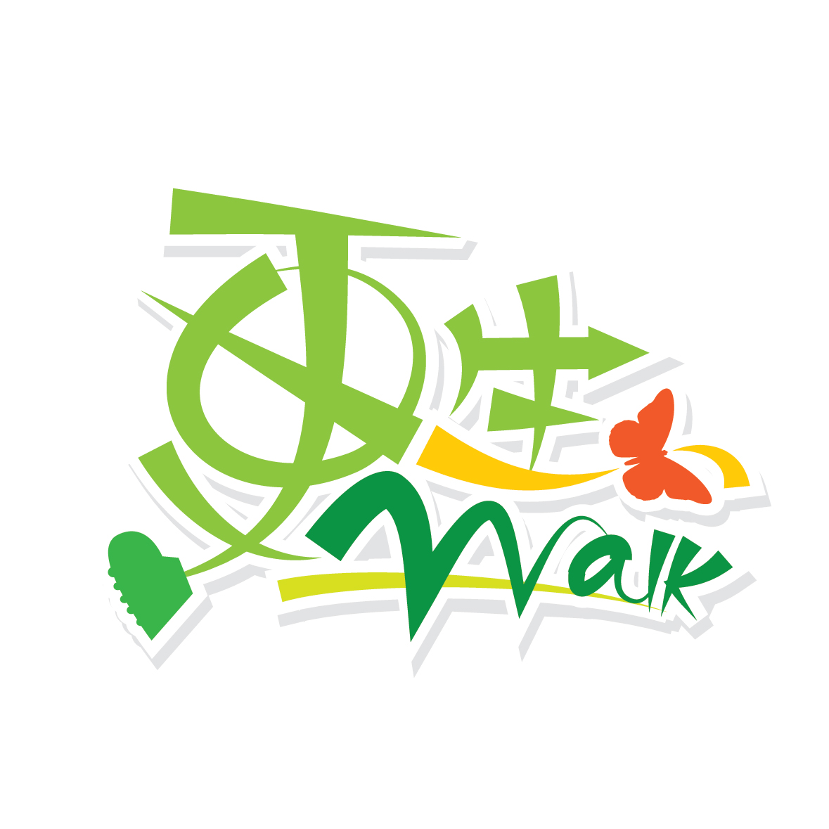

主辦機構︰

第八屆「甦Walk」慈善行 ‧ 想旅行
8th SRACP Charity Walk – Travel Around the World
參加表格 Registration Form
個人資料 Personal Information
姓名Name | 性別Gender | 聯絡方法Contact Method
中文 (姓氏) ________________ (名字) ______________________  English (First Name) __________ (Last Name) ________________ | ◻男 Male  ◻女 Female  ◻中立 Diverse | 電話 Mobile Number: __________________  電郵 Email: ____________________________________
郵寄地址 Mailing Address: ______________________________________________________________________________

參加費 Registration fee
◻ | 1張景點卡(隨機抽樣) + 1張小孩卡(免費贈送)  Including 1 Scenic Card (by random)+ 1 Child Card(free gift) | $0
◻ | 1張景點卡(自選款式) + 1張小孩卡(免費贈送)  Including 1 Scenic Card (by option)+ 1 Child Card(free gift) | $50
◻ | 全套8張景點卡 + 1張小孩卡(免費贈送)  Full set of 8 Scenic Cards + 1 Child Card(free gift) | $280
◻ | 額外捐款(請於右欄註明金額) Extra Donation (please state the amount) | $____________
總捐款 Total: |  | $____________
請選擇以下適用者 Please tick the appropriate box:
◻ 請寄回正本收據 Please send me an official receipt
收據抬頭 Receipt Recipient Name: _______________________________________________________
◻ 為節省行政開支及支持環保，本人/機構無需收據 To help save administrative costs, I do not need any receipt.
請選擇一張景點透明卡(指定款式) Please pick your designated scenic spot transparent card (by selection)
◻ | 富士山 Mount Fuji | ◻ | 卡帕多奇亞 Cappadocia
◻ | 艾菲爾鐵塔 Effiel Tower | ◻ | 泰姬陵 Taj Mahal
◻ | 大笨鐘 Big Ben | ◻ | 自由神像 Statue of Liberty
◻ | 金字塔 Pyramid | ◻ | 愛琴海 Aegean Sea

捐款方法 Payment Method
- PayMe：請於付款訊息提供姓名、電話和電郵，並截取成功捐款之頁面電郵至 walk@sracp.org.hk 或 WhatsApp (852) 5646 5397。(QR Code)
Please provide your name, tel and email in the Payme payment message. Take a screenshot of the transaction, email it to walk@sracp.org.hk or whatsapp to (852) 5646 5397.
- 支票 By Cheque：把支票(抬頭請寫上「香港善導會」或「SRACP」，並於支票背面寫上參加者之姓名)連同此表格寄回香港善導會。
Submit your donation with application form to SRACP, please state name of participant on the back of cheque and mail it to SRACP address.
- 存入銀行 Direct Deposit：善款存入香港上海匯豐銀行帳戶023-784457-838後，把存款收據連同此表格以Whatsapp (5646 5397)、電郵(walk@sracp.org.hk)、傳真(2865 3565) 或 郵寄至香港善導會。
Deposit to HSBC 023-784457-838 and send us the bank-in slip with name of participants by Whatsapp (852- 5646 5397), mail, email (walk@sracp.org.hk) or fax (28653565).
- 現金 Cash：善款連同此表格於辦公時間內(星期一至四 9am – 5:45pm，星期五 9am – 6pm)親身遞交至香港善導會。Please visit SRACP during Mon to Thu 9am – 5:45pm, Fri 9am – 6pm.
參加者請填妥此表格連同籌款額，以上述任何一種方式（請於以上空格加上「✓」號）交回。若以郵寄方式，封面請註明「甦Walk」寄往地址：香港灣仔軒尼詩道15號溫莎公爵社會服務大廈702室。
Please complete the application form with minimum sponsorship amount and submit to SRACP (Room 702, Duke of Windsor Social Service Building, 15 Hennessy Road, Wanchai, Hong Kong).

From which channel (s) do you know about this event?: ◻ 本會網站 SRACP website ◻ 本會服務單位 SRACP service units
◻ 社交平台 Social media ◻ 報章雜誌 Printed media ◻ 其他 Others: _________

備註 Remarks
- 完成報名及付款後，即表示參加者遵守及接受在此及其後所有主辦單位香港善導會所定下之一切活動條款、細則及安排。
Upon completing the registration and payment, the participant is deemed to have accepted all terms and conditions of the event, the official rules as stipulated and to those that may be later introduced by the Organizer, SRACP.
- 大會保留以是次活動照片作日後推廣用途之權利。
The Organiser reserves the right of using the photos taken in this event for future promotion.
- 活動屬自願參與性質，參加者願意承擔一切風險及責任，並無權向香港善導會追討因是次活動而引致之自身受傷、意外、死亡或任何形式的損失索償或追究責任。
Participation in the Event is voluntary and at the own risk of participants. Each participant agrees to absolve the SRACP, and any sponsors and/or supporting organisations from all liabilities arising from bodily injuries, accidents, death or other losses during or caused by the event.

私隱政策聲明 Consent to the Use of Personal Data
本人已閱讀及明白所有資料，包括參加者守則及安全指引，並願意參加由香港善導會主辦之第八屆「甦Walk」慈善行 ‧ 想旅行及遵守大會所訂的規則。同時，本人同意准許主辦機構使用是次活動之任何相片、錄像或其他任何紀錄作合法用途。
Agree that any personal data collected will be used for receiving updates, fundraising and/or event promotion purposes only. All data will be kept strictly confidential. For more information on privacy policy, please visit SRACP. If applicable, please mark the box(es).

參加者簽署 Signature： |  | 日期Date：
主辦機構︰
主辦機構︰

